Participante: Jorge Ariznabarreta
CODIGO:
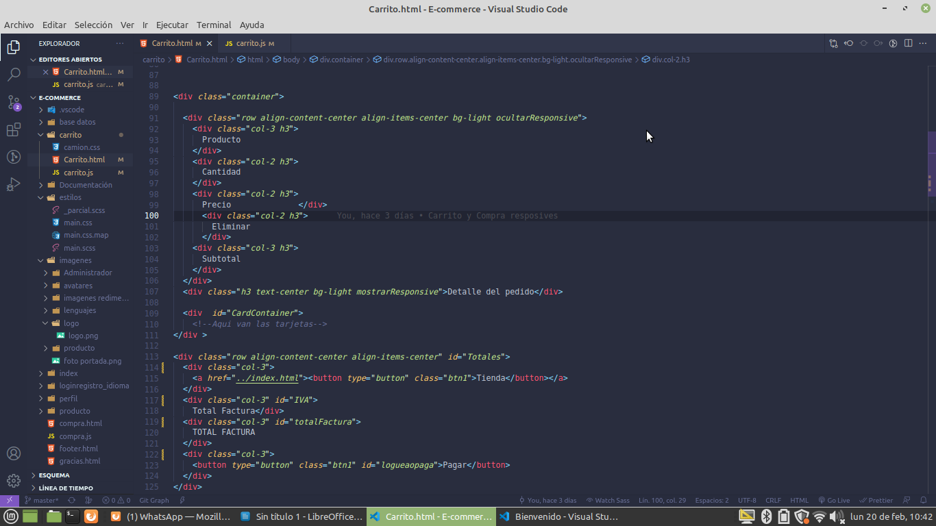
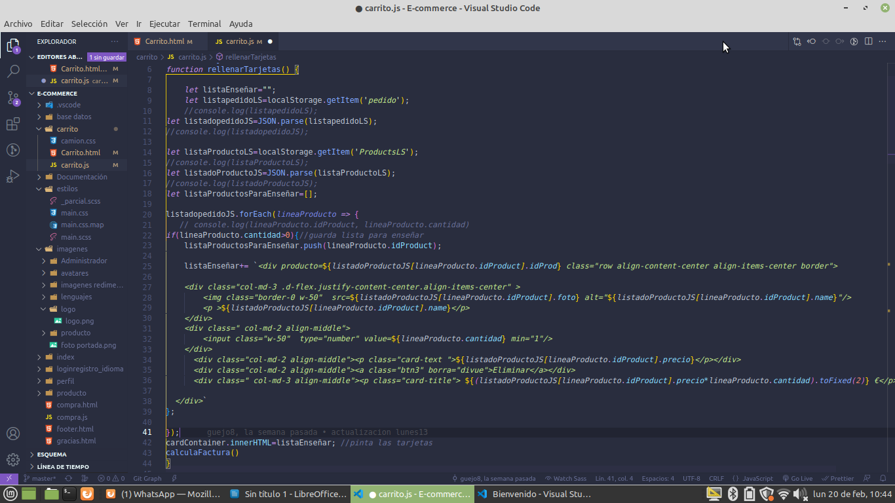
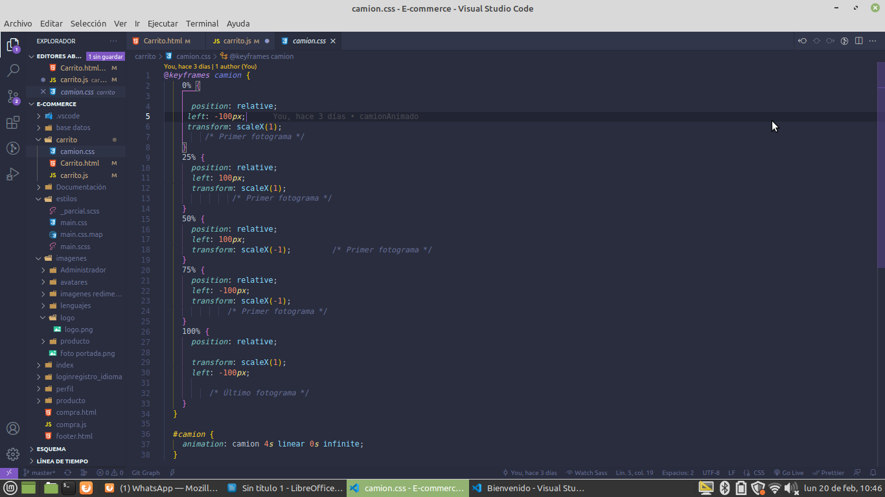

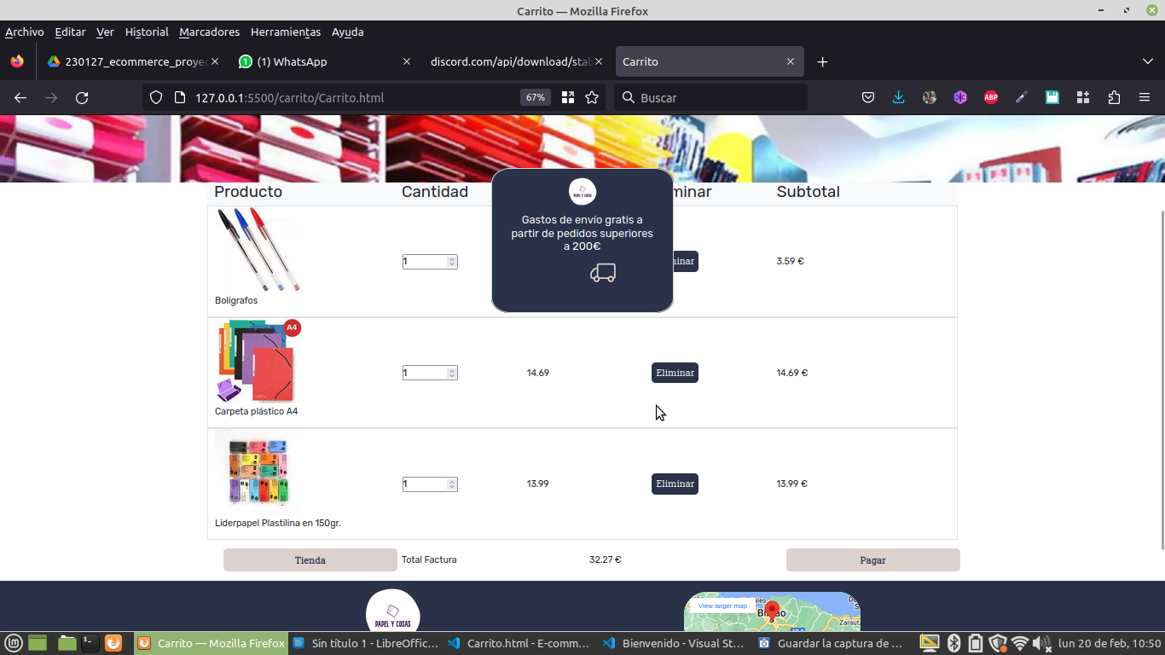
https://github.com/guejo8/E-commerce
https://trello.com/b/q5lkTSmR/proyecto-e-commerce
https://www.figma.com/files/team/1200767733120148922

